HARSH KASLIWAL

2003085

C21

**ASSIGNMENT 1**

1. Python program to implement operations of linked list

1. Display list
2. Insert at beginning
3. Insert at End
4. Insert at specified postion
5. Delete from beginning
6. Delete from end
7. Delete at specified postion
8. Delete a particular element
9. Search an element
10. Replace element at specified index
11. Forward traversal
12. Reverse traversal
13. Insert after an element

**CODE:**

class Node: def __init__(self,value,next): self.value = value self.next = next

class Linked_list:

def __init__(self):

self.head = None

def insert_at_beginning(self,value):

self.head = Node(value,self.head)

def insert_at_end(self,value): if self.head == None:

self.head = Node(value,None)

i = self.head

while(i.next): i = i.next

i.next = Node(value,None)

def insert_at_specified_position(self,value,pos): if pos == 1:

node = Node(value,self.head) self.head = node return

i = self.head while(pos != 2): pos = pos - 1 i = i.next

node = Node(value,None) node.next = i.next i.next = node

def delete_from_beginning(self):

self.head = self.head.next

def delete_from_end(self): i = self.head while(i.next != None):

prev = i i = i.next prev.next = None

del(i)

def delete_at_specified_position(self,pos):

ptr_del = self.head prev = self.head i = self.head.next

while(pos != 1): pos -= 1 prev = ptr_del ptr_del = i i = i.next prev.next = i del(ptr_del) def delete_particular_element(self,val):

i = self.head ptr_del = self.head prev = self.head while(ptr_del.value != val): prev = ptr_del ptr_del = i i = i.next prev.next = i del(ptr_del) def search_element(self,val): i = self.head count = 1 while(i.next != None): if(i.value == val):

print("Element is Present at position",count) return

else:

count += 1 i = i.next

print("Element not present in linked list") def replace_element(self,pos,val): i = self.head

if pos == 1:

i.value = val return

while(pos != 1): pos = pos – 1

i = i.next i.value = val def reverse_traversal(self):

i = self.head prev = self.head lst = [] while(i != None):

lst.append(i.value)

i = i.next

lst.reverse() print("Reverse Traversal is : ")

for i in lst: print(i,"-->",end = "")

print()

#same as forward traversal def display_list(self): if self.head == None:

print("Linked list is Empty!!!") return i = self.head linked_list = '' while(i): linked_list += str(i.value) + '-->' i = i.next print(linked_list)

def insert_after_element(self,val,ele):

i = self.head while(i.next != None): if(i.value == val):

i.value = ele print("value changed") return i = i.next print("No such element found")

if __name__ == '__main__':

ll = Linked_list()

print("Inserting elements in the beginning") ll.insert_at_beginning(10) ll.insert_at_beginning(200) ll.insert_at_beginning(18) ll.insert_at_beginning(30) ll.display_list() print()

print("Inserting elements at the end") ll.insert_at_end(20) ll.insert_at_end(40) ll.insert_at_end(50) ll.insert_at_end(60) ll.display_list() print()

print("Inserting element 100 at position 5") ll.insert_at_specified_position(100,5) ll.display_list() print()

print("Deleting the first element") ll.delete_from_beginning() ll.display_list() print()

print("Deleting last element") ll.delete_from_end() ll.display_list() print()

print("Deleting element from position 3") ll.delete_at_specified_position(3) ll.display_list() print()

print("Deleting element 20") ll.delete_particular_element(20) ll.display_list() print()

print("Searching element 18") ll.search_element(18) print()

print("Replace element at position 2") ll.replace_element(2,238) ll.display_list() print()

print("Reverse traversal of linked list") ll.reverse_traversal() print()

print("Inserting element 258 in place of 238") ll.insert_after_element(238,258) ll.display_list()

**Output:**

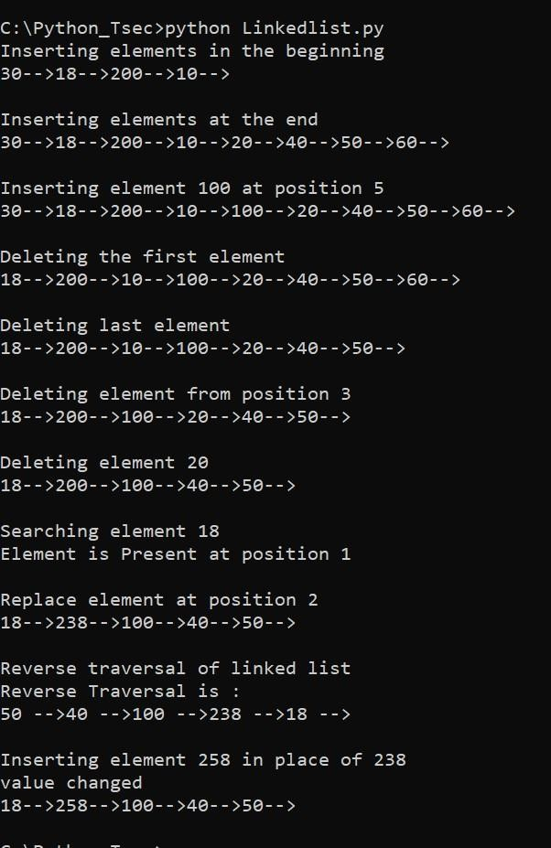

2. Python program to implement Stack data structure create class Stack with following functions.

* Push an element
* Pop an element
* Top of Stack
* Search an element
* Display stack create instance and perform all operations

**Code:**

#stack.py class Stack:

def __init__(self): self.st = [] def isempty(self):

return self.st == []

def push(self,element):

self.st.append(element)

def pop(self): if self.isempty(): return -1

else:

return self.st.pop()

def peek(self):

n = len(self.st) return self.st[n-1] def search(self,element): if self.isempty():

return -1 else:

try:

n = self.st.index(element) return len(self.st)-n except ValueError:

return -2 def display(self): return self.st

# Main Code: from stack import Stack s = Stack() choice = 0 while choice<6: print('STACK OPERATIONS') print('1.Push element') print('2.Pop element') print('3.Top of stack') print('4.Search an element') print('5.Display Stack') print('6.Exit') choice = int(input('Your choice: ')) if choice==1: element = int(input('Enter element: ')) s.push(element) elif choice==2: element = s.pop() if element == -1:

print('The stack is empty') else:

print('Popped element= ', element) elif choice==3:

element = s.peek() print('Topmost element= ', element) elif choice==4:

element = int(input('Enter element: ')) pos = s.search(element) if pos == -1:

print('The stack is empty') elif pos == -2:

print('Element not found in the stack') else:

print('Element found at position: ', pos) elif choice==5:

print('Stack',s.display()) else: break

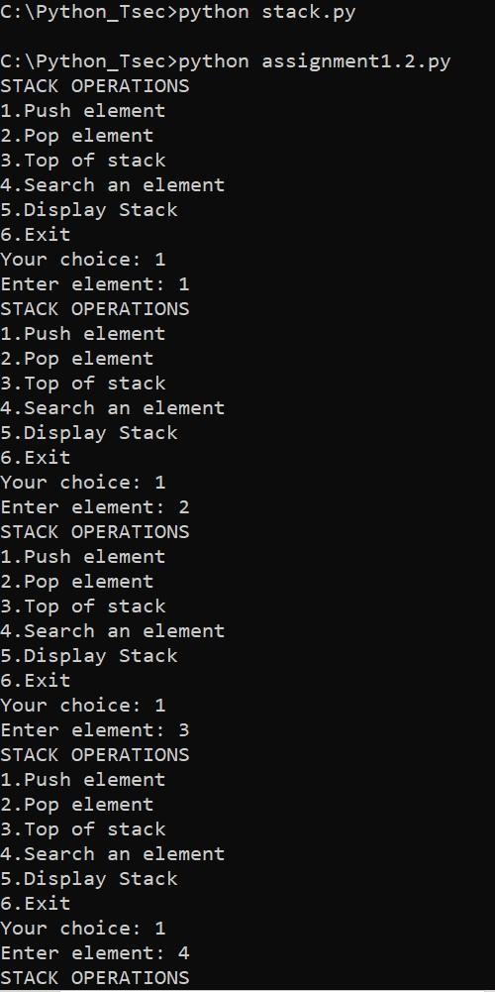**Output:**

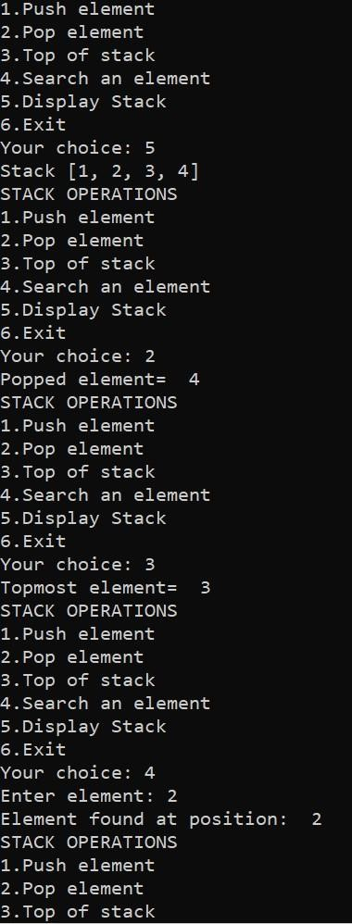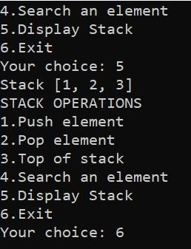

3. Python program to implement Queue data structure create class Queue with following functions.

* Insert an element
* Remove an element
* Search an element
* Display queue

**Code:**

#que1.py class Queue:

def __init__(self):

self.qu = [] def isempty(self): return self.qu == []

def add(self,element):

self.qu.append(element) def delete(self): if self.isempty(): return -1

else:

return self.qu.pop(0) def search(self,element): if self.isempty(): return -1 else: try:

n = self.qu.index(element) return n+1

except ValueError: return -2

def display(self):

return self.qu # Main

Code: from que1 import Queue q = Queue() choice = 0 while choice<5:

print('QUEUE OPERATIONS') print('1.Insert an element') print('2.Remove an element') print('3.Search an element') print('4.Display Queue') print('5.Exit')

choice = int(input('Your choice: ')) if choice==1: element = int(input('Enter element: ')) q.add(element) elif choice==2:

element = q.delete() if element == -1:

print('The queue is empty') else:

print('Removed element= ', element) elif choice==3:

element = int(input('Enter element: ')) pos = q.search(element) if pos == -1: print('The queue is empty') elif pos == -2:

print('Element not found in the queue') else:

print('Element found at position: ', pos) elif choice==4:

print('Queue',q.display())

else: break

**Output:**

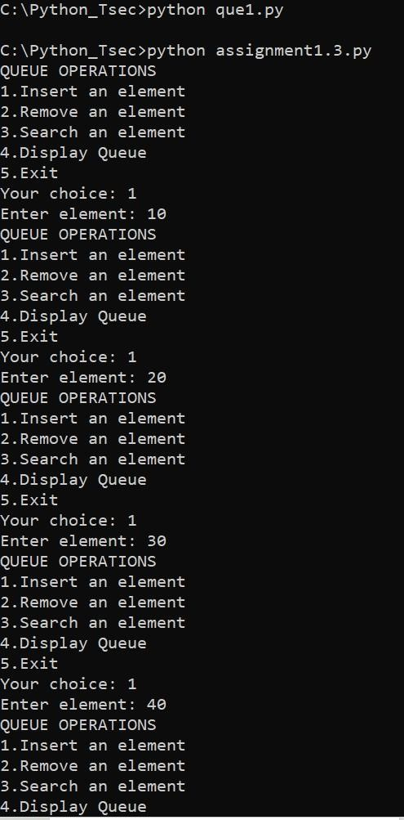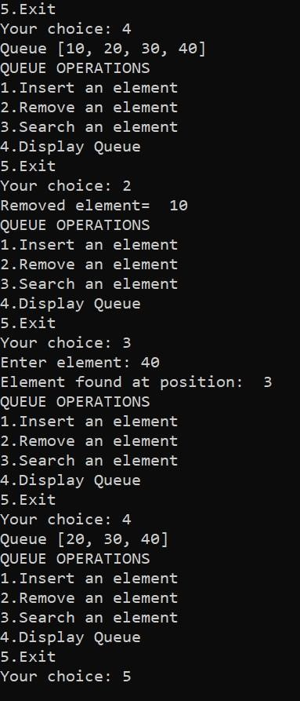

4. Python program to use deque class from collections with following functions.

* Add element at Front
* Remove element from Front
* Add element at Rear ● Remove element from Rear
* Search for an element

**Code:**

from collections import deque d = deque() choice = 0 while choice<6:

print('DEQUE OPERATIONS')

print('1.Insert an element at front') print('2.Remove

an element from front') print('3.Insert an element at rear') print('4.Remove an element from rear') print('5.Search an element')

print('6.Exit') choice = int(input('Your choice: ')) if choice==1:

element = int(input('Enter element: ')) d.appendleft(element) elif choice==2:

if len(d) == 0:

print('Deque is empty') else:

d.popleft() elif choice==3:

element = int(input('Enter element: ')) d.append(element) elif choice==4:

if len(d) == 0:

print('Deque is empty') else:

d.pop() elif choice==5:

element = int(input('Enter element: ')) c = d.count(element) print('No of times the element found:', c) else: break print('Deque=' , end='') for i in d: print(i, '

', end='') print()

**Output:**

